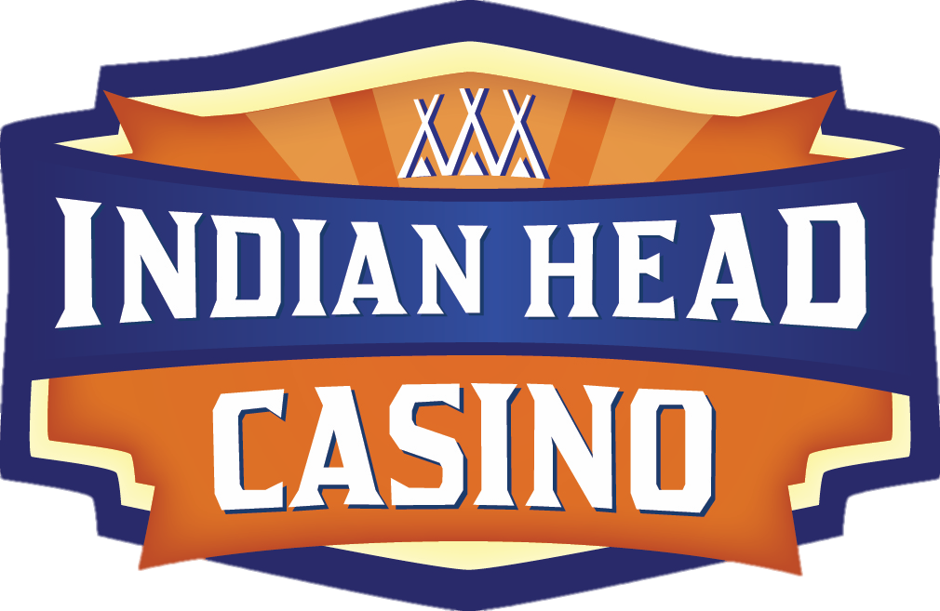

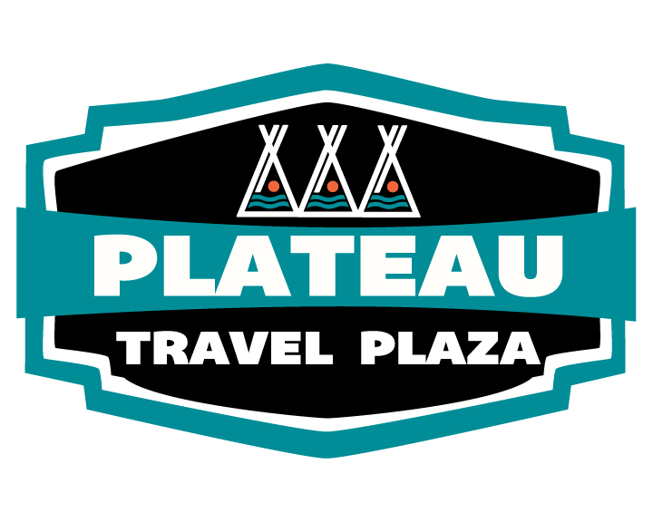

Pro-forma

Financial Statement

For the Years Ending

December 31, 2021 – 2023

**Executive Summary**

The purpose of this business plan is to provide a strategic plan for the operation of the Warm Springs Confederated Tribes, Indian Head Casino and Plateau Travel Plaza. This business plan will also showcase the expected financials and operations over the years ending December 31, 2021 to 2023. Warm Springs Indian Head Casino is a fully owned gaming enterprise of the Confederated Tribes of Warm Springs located at 3236 Highway 26, Warm Springs, OR and 215 NW Cherry Lane, Madras, OR.

**Products and Services**

Indian Head Casino primarily generate revenues from the operation of 496 Slot Machines, 6 Blackjack Tables (suspended), a 124 seat Restaurant, Lounge (temporary closed), Deli and merchandise sales. Truck Plaza primarily generate revenues from operations of Class II slot machines, convenient store, restaurant, diesel and gas pumps.

Per Oregon Office of Economic Analysis report of May 2020, Oregon Tourism Commission of April 2020 Oregon Travel Impacts and Red Circle CV-19 Casino Player Behavior Study.

* **National gaming trends**

2019 marked another record-setting year for the commercial gaming segment. Helped in part by the expansion of legal sports betting, the commercial casino sector logged its fifth consecutive year of gaming revenue growth in 2019—surging 3.7 percent to $43.6 billion, a new historic high.

At the end of 2019, Americans never had a higher opinion of our industry and nearly half said they planned to visit a casino over the next year. Consumers saw gaming as providing innovative, cutting-edge entertainment while at the same time providing economic and social benefits to local communities.

*Total nationwide consumer spending on casino gaming increased for a fifth straight year to reach a record $43.61 billion, up 3.7 percent from 2018.

Overall, 14 of the 25 states with commercial casinos reported record annual gaming revenue in 2019, reflective of strong local economies in many parts of the countries and the addition of sports betting in certain markets. Only four states reported lower casino gaming revenue in 2019 than the previous year.

*Notably, the above gaming revenue and direct gaming tax totals do not include contributions from the 524 tribal casinos operating across 29 states. Revenue figures for 2019 had not yet been released at the time of writing.

Since then, the COVID-19 crisis that erupted around the world in early 2020 has had a tremendous impact on our industry, employees, and suppliers. Within a span of 11 days, the commercial casino industry went from continued record-breaking growth to complete shutdown. The American gaming industry has never faced a bigger challenge.

Importantly, we will be able to draw on 2019’s strong foundation as the industry rebuilds. Last year, Sports betting was being legalized at an unprecedented pace, with 20 states and the District of Columbia having passed legislation allowing consumers to bet on sports with legal, regulated operators.

With every person having their mobile device, both mobile and social gaming have a huge impact on the online gambling world. As a result, there have been an increase in F2P (free to play) types of game products worldwide.

The tribal casino gaming industry has reported revenue growth in every year since the Great Recession, and 2019 saw further signs of tribal gaming fulfilling its mission of helping sovereign Indian nations to advance their economic development, with various tribal-owned gaming entities even electing to compete alongside private gaming companies in commercial casino markets such as Pennsylvania, Arkansas, and Indiana.

* **State of Oregon**

U.S. economic growth has settled in around its potential in recent quarters. The outlook is stable and the risk of recess­ion is receding. The trade war deescalated with the signing of the Phase One trade deal between China and the U.S. and financial markets calmed following the Federal Reserve’s shift in policy.

During the current recession, income taxes might not fare so poorly in comparison to other revenue instruments. Given the depth and breadth of the current economic downturn, no state revenue system will be spared from pain going forward.

While some taxes will fare better than others, all major revenue sources will face considerable downward pressure given the severity of the recession. The sudden stop in economic activity has led to the largest downward revision to the quarterly forecast that our office has ever had to make. In the baseline (most likely) scenario, General Fund and other major revenues have been reduced relative to the March forecast by $2.7 billion in the current biennium and $4.4 billion in the 2021-23 budget period.

Fortunately, Oregon is better positioned than ever before to weather a revenue downturn. Automatic deposits into the Rainy-Day Fund and Education Stability Fund have added up over the decade-long economic expansion. Oregon is expected to end the biennium with nearly $3 billion in reserves set aside, nearly 14% of the budget.

*Pre-COVID-19 data for 2019*

The Oregon travel industry continued to exhibit strong growth in 2019, as all measures of travel activity were up over 2018.

Total direct travel spending in Oregon was $12.8 billion in 2019. The annual increase from 2018 was 3.6 percent in current dollars. In real, inflation-adjusted, dollars travel spending increased by 1.7 percent. Visitor spending, excluding transportation, increased by 3.1 percent in current dollars. This is the tenth consecutive year of growth in travel spending following the recession.

*COVID_19 update from State of Oregon June 2020 Economic and Revenue Forecast slide show*



* **Central Oregon**

As of this writing very few Oregon Industry reports are available for statistics or projected industry revenue.

The Oregon travel industry continued to exhibit strong growth in 2019, as all measures of travel activity were up over 2018.

Total direct travel spending in Oregon was $12.8 billion in 2019. The annual increase from 2018 was 3.6 percent in current dollars. In real, inflation-adjusted, dollars travel spending increased by 1.7 percent. Visitor spending, excluding transportation, increased by 3.1 percent in current dollars. This is the tenth consecutive year of growth in travel spending following the recession.

* **Oregon Gaming Trends**

As of this writing very few Industry reports are available for statistics or projected industry revenue for Oregon. This lack of analytics and statistics is likely related to the current COVID-19 situation.

As IHC continues to develop a dedicated Host program our goals include continued increases in trips/spend per trip & ADT from our loyal customer base. With an emphasis on reaching the top revenue generators in our database. This is the approach industry experts most often advise as the most effective approach to recovery during the unique environment.

Promotions will continue to take on a different look with less interaction, fewer BIG prize promotions & again targeting our highest ROI (return on investment) promotional models.

The IHC continues development programs to increase carded play up at the Plateau Travel Plaza game room and at IHC. Having a marketing presence on site at PTP would improve these efforts.

Our continued goal will be to develop property amenities which will expand our market reach and give us the opportunity to extend the stay of those visitors from our customer base. Reviewing new ventures for expansion of amenities could include, sports-betting, igaming or social gaming, as well as hotel and entertainment venue and overall expansion.

**Covid-19 Specific Consideration Global**

One risk to the U.S. and global outlook is the potential human, social, and economic impacts of the coronavirus. Economically the worst-case scenario is fears over the virus are a coordinating event that serves as a recession catalyst. Other direct impact channels, however small here in the U.S., include supply chain disruptions, lower volumes of trade, reduced Chinese tourism, and increased financial market uncertainties.

A report generated by Red Circle Agency has studied a four-week period of open casino properties, in 9 states. Including 19 properties & 110,000 players.

During week four of this study we see for the first time that the volume of casino guests is strongly impacted with a considerable impact to revenue as well.

Across all the aggregated data we are seeing a loss of 18.9% of revenue and 35.2% decline in players. Individual properties range from being up 5% to experiencing a 51% decline.

Week four breaks the trends established in the first three weeks of this study and we are anxious for week five data to determine of this is the start of a new trend or an anomaly.

The results show a decline year over year, but it is not a decline in recent spend. Below we show the spend level over the last few weeks. Week four was a strong week in 2020, but it did not perform like a traditional holiday weekend, and that is to be expected.



**Indian Head Casino – Management Plan and Assumptions:**

**Casino**

As a result of upgraded gaming selections and marketing efforts, the casino’s base revenues have been projected to grow modestly over the next three years. We are projecting that Indian Head Casino’s base revenues are on unknown to the COVID issues, but we will try to get within 80% of the 2019 actual revenues for 2021 and increase revenue 4-7% in 2022 and 2-4% in 2023. We will continue to focus on our primary product (Slots) and the supporting venues to include enhanced guest service. EBITDA will increase due to better market exposure and improved operational efficiencies. Also, we need to strategize on how to deal with the increase minimum wage in Oregon.

Key focuses to achieve these EBITDA levels are:

* Monitoring, utilization, and growing of loyal patron database to create profitable traffic.
* Utilizing better customer loyalty programs; grow the number of visits and wallet share from the existing players as well as increase number of new customers.
* Continued focus on cost control management / achieve a minimum 1% increase in year-end EBITDA margin.
* Achieve a minimum 10-15% return on project capital investments.
* Achieve a daily Win Per Unit (WPU) in slots of $110 and maintain a WPU of $250 in tables; and an overall win per on carded guest of approximately $75.

**Plateau Travel Plaza**

Plateau Travel Plaza to include a 3,500-square foot convenience store, 50 seat food outlet, diesel pumps, retail gas pumps, showers, laundry, and gaming center. We will focus on growing the business through local customers, regional customers, and national trucking companies

Key focuses to achieve these EBITDA levels are:

* Monitoring, utilization, and growing of customer base and drive highway traffic into the Plaza.
* Monitor the payroll vs revenue.
* Increase all revenues by 2% over prior year

**Economic tactics:**

* Continue to measure performance
  + Service quality
  + Employee training and skill development
  + Organizational strategic focus
* Continued consistency across marketing campaigns
* Evaluation of departmental plans (customer service improvement and efficiency)
* Grow market share by highlighting benefits when compared to direct and indirect competition
* Enhanced database segmentation for stronger utilization in targeting markets
* Employ Loyalty Programs to drive incremental revenue
* Stay current with technologies

**Pro-forma Financial Statement (YE December 31, 2021-2023):**

The following pro-forma Income Statement represents Warm Springs Csino Enterprises Management plan analysis and projections for the years ended December 31, 2021 to 2023:

|  |  |  |  |
| --- | --- | --- | --- |
|  | | | |
| |  |  |  |  | | --- | --- | --- | --- | | **Indian Head Casino & Plateau Travel Plaza** | | | | | **Three Year Pro-Forma Income Statement** | | | | | **For years ended December 2021 to 2023** | | | | |  |  |  |  | |  | **2021** | **2022** | **2023** | | **Revenue:** |  |  |  | | Gaming Revenue (Casino) | 18,000,000 | 19,000,000 | 19,950,000 | | Gaming Revenue (Truck Stop) | 1,550,000 | 1,565,500 | 1,581,155 | | F&B Revenue (Casino) | 1,600,000 | 1,616,000 | 1,632,160 | | Truck Stop (net of gas) | 2,750,000 | 2,777,500 | 2,805,275 | | Other Revenue | 375,000 | 378,750 | 382,538 | | **Total Revenue** | **24,275,000** | **25,337,750** | **26,351,128** | | **Total Other Operating Expenses** | **17,235,250** | **18,243,180** | **18,445,789** | | **Regulatory Expense** | **1,550,000** | **1,581,000** | **1,612,620** | | **EBITDA** | **5,489,750** | **5,513,570** | **6,292,718** | |  |  |  |  | | **Non-operating Expense** |  |  |  | | Depreciation | 2,100,000 | 2,000,000 | 2,100,000 | | Interest Expense (PTP loan) | 282,000 | 204,000 | 162,000 | | **Total Non-Operating Expense** | **2,382,000** | **2,204,000** | **2,262,000** | | **Net Income** | **3,107,750** | **3,309,570** | **4,030,718** | |  |  |  |  | |  |  |  |  | |  |  |  |  | | | | |
|  |  |  |  |

The following pro-forma Cash Flow Sheet represents Warm Springs Casino Enterprises Management plan analysis and projections for the years ended December 31, 2021 to 2023:

|  |  |  |  |
| --- | --- | --- | --- |
| **Indian Head Casino & Plateau Travel Plaza** | | | |
| **Three Year Pro-Forma Cash Flow Statement** | | | |
|  |  |  |  |
|  | **2021** | **2022** | **2023** |
| Beginning Cash | 1,750,000 | 1,963,695 | 1,572,084 |
| Net Income | 3,107,750 | 3,309,570 | 4,030,718 |
| Depreciation | 2,100,000 | 2,000,000 | 2,100,000 |
| Capital Projects | (500,000) | (500,000) | (500,000) |
| Tribal Dividend | **(1,000,000)** | **(1,500,000)** | **(2,000,000)** |
| Tribal Return on Investment | (169,055) | (101,180) | (29,317) |
| Principle Loan Payments $18M | (2,125,000) | (2,400,000) | (2,275,000) |
| PTP Principle Payment | (1,200,000) | (1,200,000) | (1,200,000) |
| **Net Cash Flow** | **1,963,695** | **1,572,084** | **1,698,486** |
|  |  |  |  |
| **Fuel Tax to the Tribe** | **142,500** | **145,000** | **147,500** |
|  |  |  |  |
|  |  |  |  |
|  |  |  |  |

The following pro-forma Balance Sheet represents Warm Springs Casino Enterprises Management plan analysis and projections for the years ended December 31, 2021 to 2023:

|  |  |  |  |
| --- | --- | --- | --- |
| **Indian Head Casino & Plateau Travel Plaza** | | | |
| **Three Year Pro-Forma Balance Statement** | | | |
|  |  |  |  |
|  | **2021** | **2022** | **2023** |
| Current Assets | 5,000,000 | 5,000,000 | 5,000,000 |
| Capital (Net) | 16,750,000 | 15,250,000 | 13,650,000 |
| Total Assets | 21,750,000 | 20,250,000 | 18,650,000 |
|  |  |  |  |
| Current Liabilities | 1,500,000 | 1,500,000 | 1,500,000 |
| Long Term Liability | 6,300,000 | 5,100,000 | 3,900,000 |
| Net Equity | 13,950,000 | 13,650,000 | 13,250,000 |
| Total Liabilities & Equity | 21,750,000 | 20,250,000 | 18,650,000 |

**Employment Data**

Indian Head Casino Enterprises promotes tribal member employment by giving preference to those applicants who are tribal members, provided they meet the minimum qualifications needed to fill the vacant position.  It is our stance that we develop, empower, and motivate our employees and applicants to gain successful employment and career opportunities, while establishing a skilled and viable Tribal Member work force and business community.

As of 6/30/20 Indian Head Casino Employment numbers:

Description % Number of Employees

TM 52% 75

MT 7% 10

Other Indian 12% 17

Non-Indian 30% 43

As of 6/30/20 Plateau Travel Plaza Employment numbers:

Description % Number of Employees

TM 44% 22

Other Indian 22% 11

Non-Indian 34% 17

**Accomplishments in 2020 (Year Over Year January – June)**

* + COVID has but restriction on any accomplishment this year at the casino
  + PTP profitability has increased significantly

**Commitment to our Communities -** through our donation and sponsorships committee we support our local and surrounding communities. Indian Head Casino Enterprises contributed $51,000 in 2020.

**Capital Expenditures (need board approval)**

* + House behind the casino removed $275K
  + Update Surveillance Equipment $150k
  + Software and Equipment $125K